GLITTERS (Erickson, 1963, USA, AFS 579)
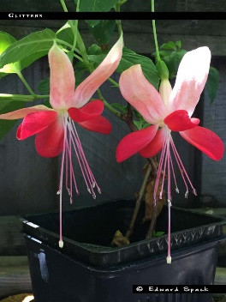
A few weeks ago I was sent a picture by an American fuchsia collector. The cultivar on the picture was bought as ‘Glitters’ but the flower was unlike the pictures of ‘Glitters’ that were shown on the FuchsiaFinder website. For that reason, the collector was not sure the identity of his plant was correct.
The original AFS description for Glitters introduced by Erickson, USA in 1963 is very brief. AFS describes Glitters as a single upright with a white tube and an orange red corolla. The newly acquired picture ticked all the boxes but so do a lot of other cultivars. The odd thing is, the pictures that already were on FuchsiaFinder did not match the written AFS description. When adding pictures to the FuchsiaFinder database, I tend to check if pictures and written descriptions match. This one must have slipped my attention, probably because all Glitters pictures I collected so far looked very similar.
My curiosity was aroused and I started investigating. Online sources seemed to agree with FuchsiaFinder. The German DDFGG database, the dutch NKvF database, the vanschaik.nu database and the NZ online registry all showed similar pictures as FuchsiaFinder did. Case closed? No. When searching the world wide web for ‘Fuchsia Glitters’, a picture drew my attention : the picture on https://davesgarden.com/guides/pf/go/186931/ was exactly like the one I was sent by the American fuchsia collector. The picture was submitted to the davesgarden website by PedricksCorner. I remembered PedricksCorner being an American Fuchsia nursery.
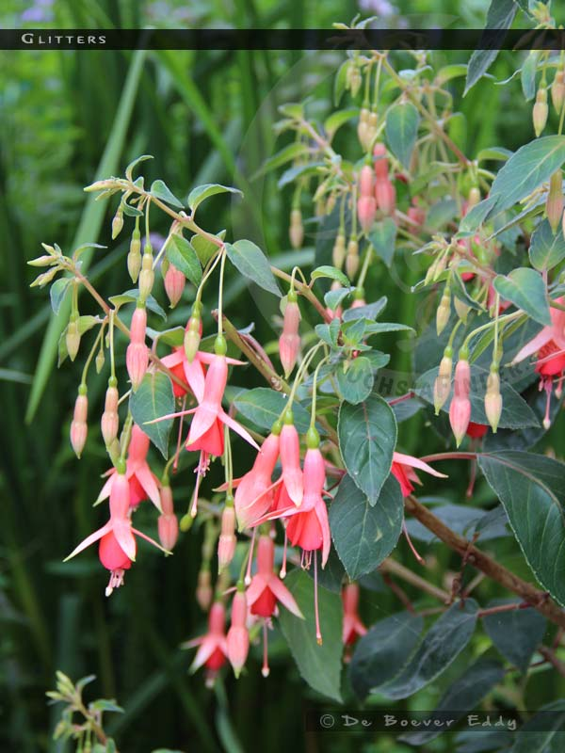
Time to use the FuchsiaFinder Cultivar Search tool to see what other nurseries sold Glitters. Glitters is still sold at a few dutch and Belgian nurseries and also Australian Fuchsia Fantasy nursery sells Glitters. Checking the various nursery websites learned that all sold the same salmon-orange single cultivar with the name Glitters. So now we had European and Australian nurseries selling a salmon orange Glitters and a US nursery selling a red-white Glitters with the distinctive features of a spreading corolla and sepals that are held fully up. Who was selling the correct Glitters?
Mr. Spack, the American collector, had helped me when I was investigating the cultivars raised by breeder Pike. I knew he had copies of Salli Dahls books covering American fuchsia cultivars so I asked him if by any chance Glitters was mentioned in one of Salli Dahls books. It was. Mr. Spack sent me a scan that showed the same white-red flared cultivar with the fully up sepals.
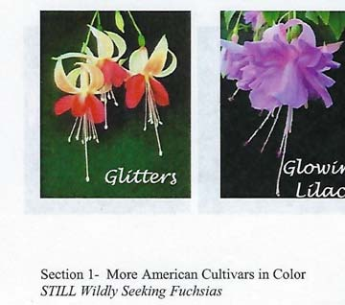
Consulting the FuchsiaFinder BookFinder tool revealed that Glitters was mentioned in a few other fuchsia publications aswell. To my knowledge Glitters is only mentioned in publications originating from the UK and The Netherlands apart from the reference in Salli Dahls book.
The descriptions can be found below.
When going through the various descriptions it becomes clear that in the fuchsia publications there are 2 distinctive sets of descriptions. The earliest publications (Boullemier and Stanley Wilson) seem to describe the white red flared cultivar with fully up sepals. More recent publications clearly describe the salmon orange cultivar.
Conclusion : My guess is that at a given point in time labels got lost or switched probably when the original Erickson cultivar was not yet widely spread in the UK. Later on the false cultivar might have been spread further to the rest of Europe, Australia and New Zealand. If this theory is valid, then it explains why in the US the original white-red cultivar is still sold. The Glitters that is sold in Europe and Australia is in my opinion not the original cultivar introduced by Erickson in 1963.
Please send remarks to fuchsiafinder@gmail.com

Descriptions for ‘Glitters’ from various sources :
SET 1 : describes a single white/red cultivar
AFS original description (1963 USA)
Glitters, 579, Erickson 1963, sgl, up, corolla orange red, sepals white
Boullemier checklist (United Kingdom, 1985-1991)
Glitters. Single. Waxy-white tube, sepals waxy-white, inside lovely salmon colour; corolla glowing orange-red. Medium sized flowers, produced in profusion with spreading corolla. (One of the parents of Celia Smedley from which it obtains its very vigorous growth (Note : this information about the parentage of Celia Smedley is wrong)). Growth upright and vigorous, heat resistant. Erickson - American - 1963 - AFS 579
Stanley J.Wilson : Fuchsias - A complete Guide to their propagation and cultivation for house and garden (United Kingdom 1974) (no picture)
Glitters (Erickson 1963). Single. Waxy-white tube and sepals, but the underside of the sepals is a lovely salmon. The spreading single corolla is a glowing orange-red. Medium-sized flowers are produced in profusion on a tall, vigorous, upright grower. An attractive easy plant to grow.
George Bartlett : Fuchsias – A colour guide (United Kingdom 1976) (no picture)
Glitters (Erickson, USA, 1963) Single H2 Bush. Tube waxy white. Sepals have similar colouring but are a lovely salmon colour on the inside; green tips. Corolla a glowing orange-red. Foliage medium green. The flowers are very freely produced on strong upright growth
NZ Fuchsia registry
Glitters (Erickson 1963 USA) Upright Bush - T.WAXY WHITE.S.WHITE OUTER.INSIDE SALMON.C.GLOWING ORANGE RED

SET 2 : describes a single salmon orange/red cultivar
A Second Colour Guide To Fuchsias (G. and A. Walker, United Kingdom) (picture similar to those on FF)
Glitters : Single.Sepals salmon-pink with green tips. Corolla bright orange-salmon. Flowers small and free, vigorous upright bush.
Eileen Saunders : Wagtails book of fuchsias Volume 1 and 2 (drawing similar to the pictures on FF)
Glitters ( Erickson 1963 USA) Tube : salmon pink - Sepals : salmon pink, paling towards green tips - Corolla : salmon orange, single - Filaments pink - style pink - Foliage medium green - Growth upright. Almost too vigorous a grower for greenhouse cultivation. best to grow this one as a summer bedding-out plant in a dry-ish, sunny position. Here it will make a tall upstanding bushy plant & bloom freely throughout the summer
500 Fuchsia's te Kijk (Miep Nijhuis, 1995, The Netherlands) (picture similar to those on FF)
Glitters : E; T diep zalmkleurig met oranje vleug; S diep zalmrose met oranjekleurige vleug, overgaand naar crème, eindigend in groene punt, aan de binnenkant licht zalmrose; C dieporanje,aan de basis lichter, donkerder streepjes, middelgrote bloem, bloeit mild; vertkt spontaan; opgaande bossige groeier; geschikt voor volle zon.
Fuchsia Lexicon (Ron Ewart, UK, 1983) (no picture)
Glitters, Erickson 1963, AFS 579. Single. Tube salmon pink, long and of medium thickness. Sepals salmon pink with green tips, short and held over the corolla. Corolla orange salmon, very bright, small and compact blooms. Foliage medium green, small to medium-sized, serrated leaves. Growth very vigorous, upright , bushy and free-flowering. Bush or summer bedder.
Fuchsia's hebben en houden (NKvF, The Netherlands, 1985) (no picture)
Glitters (Erickson 1963, USA)E. T&S : zalmrose, lichter wordend naar e (groene) toppen). C.: zalmkleurig oranje. Helmdraden en stijl : roze. Middelgroen blad. middelgrote bloem.Milde bloei. groei : rechtop. Krachtige groeier.
Lijst van in Nederland aanwezige species en cultivars van de FUCHSIA (van der Zee-Kruseman & van der Haven, The Netherlands, 1984) (no picture)
Glitters (Erickson 1963, USA, AFS 579) E. T & S: zalmrose, lichter wordend naar de (groene) toppen (SII) (wasachtig wit, van binnen zalmkleurig CL) C: zalmkleurig oranje. Helmdraden en stijl: rose. Middelgroen blad. Middelgrote bloem. Milde bloei. Groei : rechtop. Krachtige groeier. (CL en SII) (waarbij CL verwijst naar Boullemiers Checklist en SII naar Eileen Saunders boek 2)
Fuchsia's van stek tot stam (Nijhuis Miep, The Netherlands, 1986) (no picture)
Glitters (Erickson 1963 USA)- enkel. Bloembuis zalmroze, lang. Kelkbladen : zalmroze met groene punten, kort. Kroonbladen : zalmoranje. Blad : middelgroen, klein tot middelgroot. Groei : opgaand, krachtige groei. Middelgrote bloem, zeer rijke bloei
CIL Losbladige Cultivarlijst (NKvF, The Netherlands) (no picture)
1310 GLITTERS (Erickson 1963 USA, AFS 0579) Bloem : enkel, middelgrote hangende bloem met opvallende ongewone kleur; bloemen staan aan het einde van de stengels twee aaan twee in de bladoksels en vormen zo trossen. Bloembuis: lang en tamelijk dik; dof diep zalmkleurig met lichtoranje zweem. Kelkbladen : halfneergeslagen kelkbladen met iets opgebogen toppen; diep zalmroze met lichtoranje zweem, geleidelijk overgaande tot crême, eindigend in groene top; binnen kant lichtzalmroze. Kroonbladen: vrij korte compacte kroon, mooi uitkomend tussen de kelkbladen; dieporanje, lichter aan basis; donkerder adering; vanuit basis crêmekleurige smalle baan tot halverwege kroonbladen. Helmdraad: lang, roze. Helmpknop: roze. Stuifmeel: crême. Stijl: lang, wit. Stempel: crême, gelobd. Bloei: mild. Bloeitijd: normaal. Knop: langwerpig, zalmroze met groene top. Blad: middelgroot, langwerpig tot lancetvormig; puntige top; puntige voet; getande rand; donkergroen blad met geel-groene zweem; lichtere nerven; voet hoofdnerf en bladsteel rood. Groeiwijze: rechtopgaande krachtige groeier; bossige struik, die spontaan vertakt. Kweekwijze: struik voor zonnige plaats; mooie sterke fuchsia door bladkleur in combinatie met fraai-gekleurde knoppen: zalmroze met groene toppen en de bloemen.

Pictures for Glitters from various sources :
- https://davesgarden.com/guides/pf/go/186931/
- https://pics.davesgarden.com/pics/2009/07/29/PedricksCorner/d986d1.jpg
- https://fuchsiafinder.com/wp-content/uploads/2019/03/600x800EdwardSpack-Glitters.jpg
- Salli Dahl's book 'Still Wildly Seeking Fuchsias'
- https://fuchsiafinder.com/fuchsia/glitters/
- https://www.ddfgg.de/fuchsien/fuchsienverzeichnis/fuchsienverzeichnis_ausgabe_name.php?num=5615&sprache=englisch
- https://vanschaik.nu/_data_sigrid/public/index_gb.php
- http://fuchsiavereniging.nl/component/jshopping/product/view/1/4742
- http://nzfuchsia.co.nz/wp-content/uploads/Glitters.jpg
- book A Second Colour Guide To Fuchsias (G. and A. Walker, United Kingdom)
- book Eileen Saunders : Wagtails book of fuchsias Volume 1 and 2
- book The Fuchsia Album Volume 3
- book 500 Fuchsia's te Kijk (Miep Nijhuis, 1995, The Netherlands)

